# day 2 1 area plot

year=c(2015,2016,2017,2018,2019)

revenue=c(30,35,40,45,50)

plot(year,revenue,type="n",main="yearly revenue",xlab="year",ylab="revenue",ylim=c(0,max(revenue)))

polygon(c(year,rev(year)),c(revenue,rep(0,length(revenue))),col="green",border="blue")

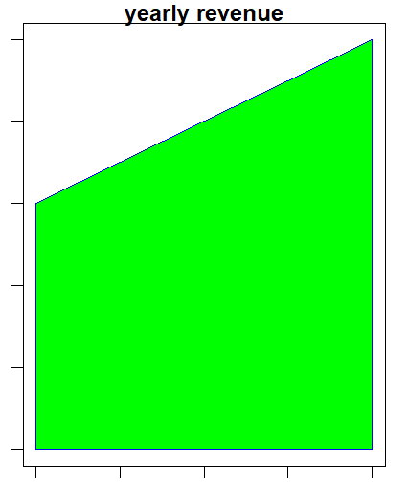

#day 2 2 step plot

month=c("jan","feb","mar","apr","may")

sales=c(100,200,300,400,500)

plot(sales,type="s",main="step plot",xlab="month",ylab="sales",col="blue",lwd=2,xaxt="n")

axis(1,at=1:length(month),labels=month)

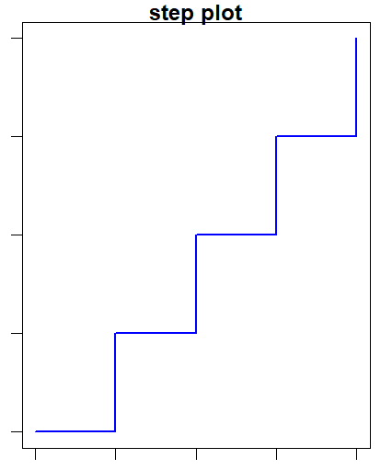

#day 2 3ridgeline plot

library(ggridges)

temperature_data<-data.frame(

city=c("city1","city1","city1","city2","city2","city2"),

temperature=c(20,21,19,22,23,24)

)

library(ggplot2)

ggplot(temperature_data,aes(x=temperature,y=city))+

geom_density_ridges()+

labs(title="temperature",x="temperature",y="city")

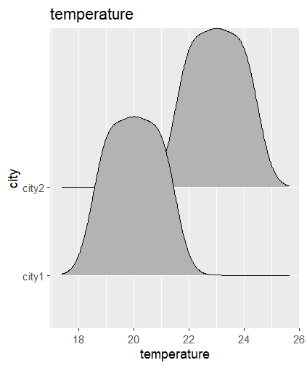

#day 2 4 dumbell

library(ggplot2)

library(ggalt)

product = c("A","B","c","D","E")

before =c(200,300,400,500,600)

after=c(250,350,450,550,650)

ggplot()+

geom_dumbbell(aes(y=product,x=before,xend=after),

size=1.5,colour="blue",size_x=3,size_xend=3,

color_x="red",color_xend="green")+

labs(title="before and after",x="sales",y="product")+

theme_minimal()

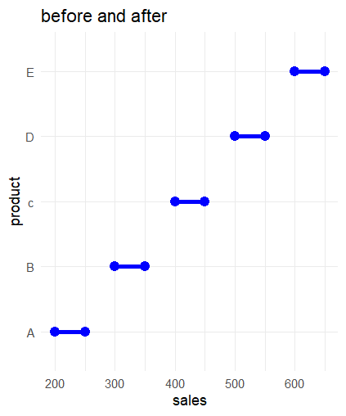

# day 2 5 lollipop plot

library(ggplot2)

Region <- c("North", "South", "East", "West")

Sales <- c(150, 200, 180, 210)

ggplot() +

geom_segment(aes(x = Region, xend = Region, y = 0, yend = Sales), color = "blue", size = 1) +

geom_point(aes(x = Region, y = Sales), color = "red", size = 4) +

labs(title = "Sales by Region", x = "Region", y = "Sales") +

theme_minimal()

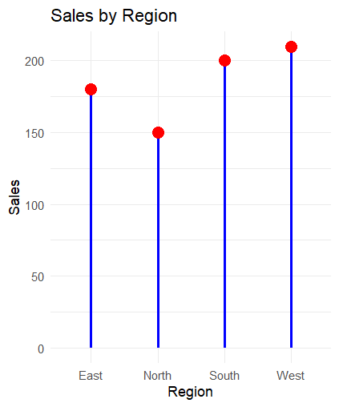

#day 2 6 saphagatti plot

library(ggplot2)

Month <- c("Jan", "Feb", "Mar", "Jan", "Feb", "Mar")

Product <- c("A", "A", "A", "B", "B", "B")

Sales <- c(100, 150, 130, 120, 140, 160)

sales_data <- data.frame(Month, Product, Sales)

ggplot(sales_data, aes(x = Month, y = Sales, group = Product, color = Product)) +

geom_line() +

geom_point() +

labs(title = "Sales over Time by Product", x = "Month", y = "Sales") +

theme_minimal()

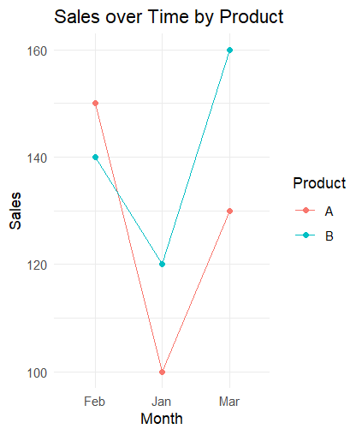

#day 2 7 waterfall plot

library(waterfalls)

# Create a data frame with the appropriate structure

profit_loss_data <- data.frame(

labels = c("Jan", "Feb", "Mar", "Apr", "May"),

values = c(100, -20, 50, -10, 80)

)

# Plot waterfall plot

waterfall(profit_loss_data, fill_by_sign = TRUE)

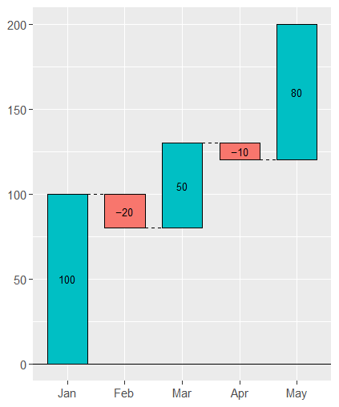

#day 2 8 hexa bin plot

xy_data <- data.frame(

X = c(1, 2, 3, 4, 5, 6, 7, 8),

Y = c(2, 3, 4, 5, 6, 7, 8, 9)

)

# Plot hexbin plot

ggplot(xy_data, aes(x = X, y = Y)) +

geom_hex() +

labs(title = "Hexbin Plot",

x = "X",

y = "Y") +

theme_minimal()

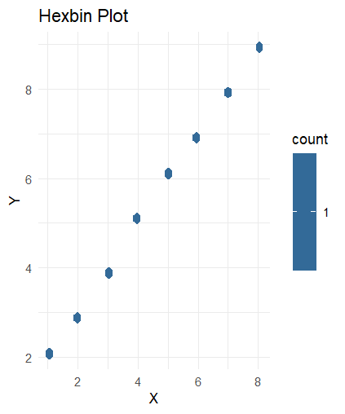

# day 2 9 chrod plot

library(circlize)

# Create a data frame

chord_data <- data.frame(

From = c("A", "A", "B", "B", "C"),

To = c("B", "C", "C", "D", "D"),

Value = c(10, 20, 15, 25, 30)

)

# Plot chord diagram

chordDiagram(chord_data)

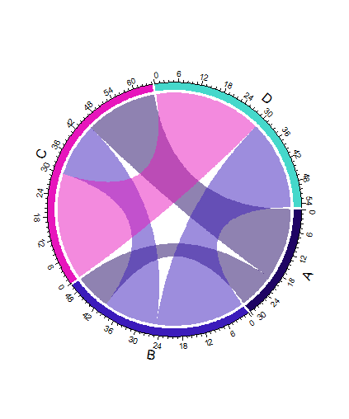

# day 2 10

library(lubridate)

library(ggplot2)

# Create a data frame

activity_data <- data.frame(

Date = as.Date(c("2023-01-01", "2023-01-02", "2023-01-03", "2023-01-04", "2023-01-05")),

Count = c(10, 12, 15, 8, 20)

)

# Add weekday and week of year columns

activity_data$Weekday <- wday(activity_data$Date, label = TRUE)

activity_data$Week <- week(activity_data$Date)

# Plot calendar heatmap

ggplot(activity_data, aes(x = Weekday, y = Week, fill = Count)) +

geom_tile(color = "white") +

scale_fill_gradient(low = "white", high = "blue") +

labs(title = "Daily Activity Count",

x = "Weekday",

y = "Week",

fill = "Count") +

theme_minimal()

